HTML Document

# Documented by: Sarbaja Adhikari

HTML stands for **Hyper Text Markup Language**. Hypertext Markup Language (HTML) is the standard markup language for creating web pages and web applications.HTML is a format that tells a computer how to display a web page. HTML describes the structure of a web page semantically and originally included cues for the appearance of the document. An HTML file is a text file containing small markup tags that tell the Web browser how to display the page. An html file must have an htm or html file extension.

Basic HTML Structure

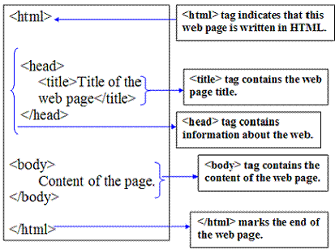

HTML TAGS

HTML tags are used to **mark-up HTML elements**. Tags are instructions that are embedded directly into the text of document. It is a signaltothebrowser that it should do something other than just throw some text on the screen. HTML tags begin with open angle bracket < and end with close angle bracket >.HTML tags are **not case sensitive**, <b> means the same as <B>

# Paired tags

A tag is paired if it comes with a companion tag. <B>This is BOLD Text</B>. e.g. < B> is a paired tag as it along with its companion tag </B> causes the text contained between them to be rendered in bold. Opening tag <B> activates the effect and Closing tag turn the effect off.

# Singular Type

Stand-alone tags does not have a companion tag e.g. <BR> or <HR> is a singular tag. Line needs a Break<BR>

# Logical Tags

Logical tags are **designed to describe (to the browser) the enclosed text's meaning**. An example of a logical tag is the <strong></strong>tag.

# Physical tags

Physical tags **provide specific instructions on how to** display the text they enclose. Examples of physical tags include:

<b>: Makes the **text bold**.

<big>: Makes the text usually **one size bigger** than what's around it.

 <i>: Makes text **italic**.

Physical tags were invented to add style to HTML pages **because style sheets were not around**, though the original intention of HTML was to not have physical tags.

# Nested tags

Tags may appear within other tags, e.g. the <body>tag also contains other tags, like the <b>tab.

Eg. <p><b><em></p></b></em>

document object model

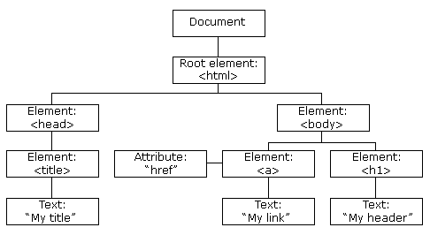

The **Document Object Model** (**DOM**) is an application programming interface (API) for valid HTML and well-formed XML **documents**. It defines the logical structure of **documents** and the way a **document** is accessed and manipulated.

CASCADING style sheet(css)

Cascading Style Sheets (**CSS**) is a style sheet language used for describing the presentation of a document written in a markup language.

# three levels of css

## inline css

* The simplest form of applying styles to a web page is by using inline styles.
* The style is applied in a line of your XHTML, so it is called an inline style.
* It is the least powerful style application because it only applies to the line you put it in and not to the whole page or many pages.
* Inline styles override any other style applied to a web page.
* Inline Styles are placed within the particular tag you wish to format.
* E.g. <h1 style="color:blue">Some text</h1>

## embedded css

* applied to an **entire document**
  + Redefine appearance of all occurrences of tag (middle)

## linked css

External file of declarations specified for **any number of documents** in an entire site

# selectors

## type selector

Type selectors are those selector which gives style to the elements we select. For example p{color:blue;}

## class selector

Class selectors are those selector which has a (.) in beginning of a class name and also an ID selector. For example .red{color:red}

## id selector

ID selector is a name preceded by a hash character. For example: #two, two is the id given.

## pseudo selector

Pseudo-class is a keyword added to selectors that specifies a special state of the element to be selected. For example: a:visited

## combination selector

Combination is a selector can contain more than one simple selector.

why bootstrap???

# Easy to use

It is extremely an easy and speedy procedure to begin with Bootstrap. Bootstrap is very adaptable too.

# Responsiveness

The fluid grid layout amends vigorously to the appropriate screen resolution, thus crafting a mobile-ready site is a smooth and easy task along with Bootstrap. With the use of ready-made classes of Bootstrap, we can recognize the number of spots in the grid system that you would like each column to engage in.

# Speed of Development

Bootstrap lets us to use ready-made coding blocks in order to assist you in setting up.

# Customizable Bootstrap

The Bootstrap can be customized as per the designs of our project. The web developers can make a choice to select the aspects which are required which can be simply complete by utilizing Bootstrap customize page.

# Packed javascript Components

Bootstrap approaches with a pack of JavaScript components for including the functionality that crafts it in simple way for operating things, such as tooltips, modal windows, alerts, etc.